Polytechnic Campus Event Planning Guide

Table of Contents
ASU Values & Standards to Keep in Mind When Planning Events 2
Event Checklist & Recommended Timeline 2
Types of Events Commonly Seen Around Polytechnic and all of ASU 6
ASU Organizations & Leadership 7
Selecting a Date & Time for your event 7
Selecting a Location 8
Renting Equipment for Events 11
Food at Events 12
Event Forms and Paperwork 14
Parking and Transit Services for Events 16
Things to Remember When Planning an Event 16
Marketing for Events 16
Volunteer & Event Staff Management 19
Contacting Non-ASU Vendors for Events 23
Event Sustainability 24
Appendix 25

ASU Values & Standards to Keep in Mind When Planning Events

ASU Charter
ASU is a comprehensive public research university, measured not by whom we exclude, but rather by whom we include and how they succeed; advancing research and discovery of public value; and assuming fundamental responsibility for the economic, social, cultural and overall health of the communities it serves.

ASU Mission & Goals: 2016 And Beyond
- Demonstrate leadership in academic excellence and accessibility
- Establish national standing in academic quality and impact of colleges and schools in every field
- Enhance our local impact and social embeddedness

https://president.asu.edu/about/asucharter

Event Checklist & Recommended Timeline

This is a rough estimate on when event tasks should be completed when planning an event on campus. Keep in mind not all events are alike and the timeline and tasks may change depending on what is needed for the event.

8-10 weeks before event (pre-planning):
- Establish event goals and objectives (purpose of the event, format, target audience, how to promote EOSS and NAMU goals, etc.)
- Select a date
  - Be sure to consult PULSE and University Wide calendars for potential
conflicts or opportunities for collaborations
  - Check the university and college event calendars, academic calendar, and religious holiday calendar for an appropriate date
  - Check the calendar of anyone who is requested to attend,
particularly the deans, chairs or directors, and/or President Crow
- Who is in charge of this event and who is coming to the event? How many
guests are expected?
- Identify location for the event and place a hold on the venue
- Present idea to fellow staff to receive feedback
- Develop marketing plan (larger events)
- Contact desired speakers/entertainers/performers etc. (if applicable)
- Identify and contact potential sponsors or partners
- Get applicable cost estimates (i.e. location rental, catering, equipment, talent, fees, etc.) to create a budget proposal
*To access spreadsheet: right-click table, select “Worksheet Object”, then “edit”

6 weeks before event:
- Finalize budget estimates
  - Helpful tips here: http://helloendless.com/how-to-create-your-event-budget/?utm_campaign=Created%20Content&utm_content=35846222&utm_medium=social&utm_source=linkedin
- Submit Funds Request Form(known also as EAF, ERF by some departments) for all outside vendors and purchases
- If your event involves a contracted performer, finalize the contract details, travel and accommodation details, and get appropriate promotional materials
- Read all contracts carefully before signing and make sure you know any important deadlines such as guarantee due dates, cancellation dates, and power needs
- Confirm location reservation
- Determine your physical space set-up – theatre-style, round tables, banquet tables, etc.
  - Consider the needs of people with access requirements when selecting
the layout of the space
- Know when you can get in and start setting up for the event
- Determine if any special equipment is needed and reserve it

4 weeks before event:
- Confirm any catering once Funds Request Form is approved
- For performers: confirm travel/accommodation details, and request details of the performance
- Marketing
  - Assemble your guest list
  - Send out a “save the date” note, if appropriate
  - Develop a promotional plan, including print and electronic materials – posters, flyers, invitations, tickets, programs, etc.
  - Send out invitations at least four to six weeks before the event (don’t forget a parking map)
  - Design a program for the event and send to the printer (if applicable)
  - Design and order signs
  - Select the method for RSVPS: phone, email, or website
  - Add your event to the university and college event calendars

2 weeks before event:
- Last acceptable day to distribute print marketing
- Order promotional items, awards, and gifts (if using a logo, keep in mind the graphic standards of the university)
- Continue social media push

1 week before event:
- Meet with event leads and ensure all details are taken care of
- Prepare a diagram of the event setup for you and your vendors
- Confirm time and location with all vendors and provide setup itinerary to them
- Give a guarantee number to the caterer
- Confirm media attending (if applicable)
- Ensure you have requested enough additional staff for event
- Check registration numbers and send reminder emails to attendees (if applicable)
- Last push for registration if numbers are low
- Continue online marketing strategy
- Plan the color scheme or theme and purchase/order appropriate décor (flowers, balloons, etc.)
- Make any changes to rental equipment necessary to reflect the number of people that you guaranteed
- Print name tags and or tent cards and have a supply of blank ones
- Prepare miscellaneous items to bring to the event: pens, pads, equipment, documents, presentation, badges, extra equipment, business cards, printed handouts of material that will be covered, etc.

1 day before event:
- Ensure all signage is in place
- Ensure registration and media tables are prepared and stocked with necessary items (attendee lists, paper, pens, name badges, etc) (if applicable)
- Ensure all promo items, gifts, plaques, trophies, etc. are on site

Event Day:
- Ensure you have copies of any necessary details (phone numbers, attendee lists, directions, etc)
- Ensure event staff is informed of procedure should problems arise
- HAVE FUN!

Within 7 days of event:
- Gather and submit all financial forms and documents to appropriate channels (receipts, invoices, signed Funds Request Form, Business Meals Form, DPSO, etc.)
- Conduct post-event survey of attendees to get feedback
- If applicable, send thank you notes to special guests, sponsors, performers, etc.
- Conduct thorough evaluation
- Wrap up the budget - record the actual cost compared to the estimated cost.
- Document – save copies of emails, contracts, orders, guest lists, notes from meetings, etc.
- Complete your past event recording

Types of Events Commonly Seen Around Polytechnic and all of ASU

Traditional/Annual/Semi-Annual Poly Events
- Blues & BBQ; Welcome Week in August
- Club Hub; Within first few weeks of semester
- Murder Mystery; Family weekend
- Devils Royale Casino Night; Homecoming week
- Poly Turnaround Trip; Varies each semester
- Drumstix Dash; November
- Relay for Life at ASU Polytechnic; March
- Late Night Breakfeast; Last full week of classes each semester
- Fulton Polytechnic Career Fair; Fall and Spring
- Career Exploration Night; Fall, freshman event
Other common Polytechnic events
- Movie nights
- Heritage/theme celebrations (Ex. Hispanic Heritage, Earth Week, Consent Week)
- ASU sporting away-game viewings
- Small concerts
- Open mic nights
- Small activity
- Dinners/BBQ
- Service and Educational
- Off campus
Traditional ASU events at other campuses
- Homecoming Week
- Devilpalooza

ASU Organizations & Leadership

EOSS
- Residential Housing Association (RHA)
- Programing and Activities Board (PAB)
- Undergraduate Student Government (USG)
- Union Staff
- Sun Devil Fitness Center (SDFC)
- Changemaker Central

https://eoss.asu.edu/

Selecting a Date & Time for your event

Check fellow ASU leadership and organization calendars to find available dates:
https://orgsync.com/234/community/calendar?view=calendar
https://asuevents.asu.edu/
https://innercircle.engineering.asu.edu/calendar/

If you are planning an annual/recurring event, it is recommended to select a date that is the same or close to the same event that occurred last time.
Ensure there will be adequate planning time for this event.

Note: No organizations may schedule or sponsor any events during the final exam period. Events are only permitted to occur during the academic year. Events are not allowed to occur during the winter break, spring break or summer break period. This does not include alternative spring break or participation in events scheduled by conference, regional, or national affiliates. Exceptions to this policy can be made with approval. No exceptions will be made for the use of university Classrooms during this time.
Info from: Student Org Handbook

Selecting a Location
There are a variety of great locations both indoor and outdoor on the Polytechnic campus to host an event. Each location has different features and may be suited for some types of events more than others. It is important to know whether or not any special needs can be accommodated for the location(s) of the event.

Things to keep in mind when selecting a location:
- The date of the event and a list of backup dates.
- The time of the event and whether you will need early access.
- Number of persons in attendance.
- Setup and audio/visual equipment needs.
- Food/beverage needs.
- Does the location have a preferred caterer you are required to use?
- What is on the floor? (walking on a cement flooring will be noisy while carpet softens most sounds)
- Does the room have the right acoustics to accommodate your needs?
- Is the building open during the event time or is it only accessible with a key card after certain hours of the day?
- Check when your suppliers can access the area for delivery and pickup.
- Do you have to do the room setup (arrange the tables and chairs) or is that service included?
- Is the location easily accessible by car? If you are providing transport, such as a coach or minibus, ensure that this is accessible too.
- Consider carefully the arrangements for car parking and dropping off passengers at the venue.
- If outside:
  - Will it be lit up enough at night?
  - Is the space shaded?
  - Do you have access to restrooms close by?
  - Do you need heaters or cooling fans?
  - What is your rainy day backup plan?
  - Check to see if you need to have sprinklers turned off for
your event.

Room Size Estimates
For a rough estimate of the size of the room needed, multiply the number of people by the appropriate square footage per person from the formulas below. To determine if a certain meeting room can accommodate a desired setup, divide the room’s total square footage by the appropriate square footage per person from the formulas below. This is only a rough estimate. Room configurations always depend on the shape of the room, what is already in the room that cannot be moved, the amount of décor and other variables.

Below is a list of the event locations on the Polytechnic campus with certain specs:

Indoor
Cooley Ballrooms
  - Full ballroom be split in three
  - A,B,C can seat 148 classroom, 224 banquet, 400 theater
  - 1/3 takes 32 U, 40 square, 56 classroom, 64 banquet, 120 theater
  - 2/3 takes 40 U, 48 square, 112 classroom, 156 banquet, 300 theater
  - Building has piano and small stage
  - 3 total screens with projectors in sealing,
  - Bring laptop
  - Can provide AV help if needed
- Student Union
- Sun Devil Fitness Center (SDFC)
  - Have three large basketball courts, one separated by wall
  - Two racket ball courts
  - Three multipurpose rooms that can seat from 30-49 people
  - You need to rent equipment for all exercise rooms listed above.
  - Wellness center for 20 with movable furniture
- Wellness Suite
- Citrus Dining Hall
- Devil’s Den
  - Room for students to relax in with sofas nice size
  - Can hold up to 50 people
  - Not available during lunch when school is in session
- Century Hall: Multi-Purpose Room, Group Study Room, Solution Space
  - Beautiful Courtyard with BBQ and limited seating available
  - Large lawn
  - Multipurpose area, two rooms or it can be combined into one room.
  - There are 24 seats and 12 tables per room--combined holding 48 seats
  - However, if configured a certain way, the room can accommodate up to 60 guests with additional chairs
  - AV equipment is included
  - You can use any caterer on the approved list for this venue
- Aravaipa Auditorium
- Agribusiness Center
- Applied Arts Pavillion Black Box Theater & Outdoor Stage
  - Can seat 120-160 people
  - You need to rent equipment for the room
  - Limited lighting in the room
  - The room has large doors that can open into a patio area creating a great indoor/outdoor reception atmosphere when weather permits.
  - You need to call request FACMAN to open the doors if you need them open
  - You can use any caterer on the approved list for this venue
- Picacho Auditorium
- Startup Labs
- Academic Classrooms
  - Poly has multiple nice size lecture halls that can seat from 100-423
  - Booked online through Astra by assigned scheduler in your department
  - For problems or questions contact Lisa Frank, lfrank@asu.edu, 480-727-1116
  - Can be difficult to get during the school year
  - No food is allowed in academic facilities, however several of the halls have larger foyer where you can reserve food before or after your event
- Library
Outdoor
- Union Patio/lawn
- SDFC Sports Fields
- SDFC Patio
- Field west of Admin Building
- Century Hall Lawn
- Agribusiness Center Patio
- Fields south of Warner, Santa Catalina, & Palo Blanco

Location spec info provided by: Kristin Olafs

Info on reserving these locations:
https://drive.google.com/a/asu.edu/file/d/0B6KvLj5fij4EWWpuQTU1NE1uY28/view?usp=sharing
Academic Facilities & Classrooms
Send an email request to Classroom Scheduling at rooms@asu.edu with the following information:
1. Organization Name
2. Requester Name
3. Advisor Name
4. Additional organization members authorized to make reservations
You will be provided with instructions for the web-based reservation system (https://astra.oasis.asu.edu/astraweb/). Once the reservation is complete, you will receive a confirmation. PLEASE forward that confirmation to your advisor. Use of academic Student facilities is a privilege available to registered student organizations. Food and beverages are not allowed in classrooms. Please be respectful and adhere to all policies to allow for future use of this privilege.
Polytechnic Specific Locations
- Citrus Dining Pavilion, Polytechnic: Reservations for Citrus, Devils Den and the Private Dining Room are available at https://eoss.asu.edu/polyunion
- Student Union, Polytechnic: Reservations for the Student Union Cooley Ballrooms and the Student Union Conference Room can be made by submitting a request at https://eoss.asu.edu/polyunion/reservations
- Sun Devil Fitness Complex (SDFC): Fields, gyms, pool, and multipurpose rooms are available for use. For more information, email Jeff.Bricker@asu.edu

To see the layouts of some popular event locations see the appendix at the end of this guide.

Renting Equipment for Events

There is a lot of equipment on the ASU Poly campus that can be used for events.
Below is a list of equipment available for rent from different organizations on campus:
- Student Union:
  - Portable stage
  - Audio and Video Equipment
  - Extension cords
- Sun Devil Fitness Center (SDFC):
  - Sporting/outdoor activity equipment
  - Extension Cords & Power boxes
  - Tables
  - Chairs
  - Large outdoor inflatable movie screen
- Residential Housing Association (RHA):
  - Outdoor & Board Games
- Programing and Activities Board (PAB):
  - Event décor & Supplies
  - Games
- Undergraduate Student Government (USG):
  - Event SWAG
- Parking and Transit Office (PTO):
  - Road blocking signs
- Other Sources:
  - Moving and Event Services: https://fdm.apps.asu.edu/FM/EventRequest/
  - ASU table skirts, banners, etc.: https://specialevents.asu.edu/catalog
  - Tempe Campus Grounds Maintenance (sprinkler, fountains, flowerbeds, lawn care)
Facilities Management at 480.965.3633 or facman@asu.edu
  - Facilities Management for all campuses https://cfo.asu.edu/construction-at-asu
  - Request to hang a banner: https://fdm.apps.asu.edu/FM/BannerRequest/
  - Sign Services at 480.965.1357 or signs@asu.edu, https://cfo.asu.edu/sign-shop-services
  - Preferred vendors at ASU: https://cfo.asu.edu/purchasing.sunmart
  - Mail services https://cfo.asu.edu/special-services

For equipment or event needs that are not able to be handled within ASU, the University has contracts with outside event management companies. Two of these companies are: ProEm and Classic Party Rentals. They provide a wide array of event support services such as: table, chair, canopy, and portable restroom rentals as well as security and other staff support related services.
https://classicpartyrentals.com/ http://proem.org/

Food at Events
General Rule:
No home prepared food or drink is allowed at campus events sponsored by student organizations. Individual students are allowed to bring their own brown bag or lunch box meal. However, they may not supply homemade food to others.
- Pre-Packaged foods from a reputable company are permitted
- Aramark is the exclusive caterer for these ASU locations on the Polytechnic campus: Student Union, Citrus Dining Pavilion, Devil’s Den & Mesquite Café
  - They ask that services be scheduled 2 weeks before the event. Aramark can be contacted on the Polytechnic campus by calling 480-727-1440 or sending an email to: ASUCateringPolytechnic@gmail.com

If Aramark is not being used to cater an event then a food waiver for the caterer or food provider being used must be submitted at least 14 days before the event.

The food waiver form can be accessed here:

TEMPORARY FOOD SERVICE AND PREPACKAGED FOOD VENDING

Applications for Temporary Food Establishment Permits are available at the Student Health Center web site at https://eoss.asu.edu/health/foodsafetyTEST

Completed applications must be submitted a minimum of 14 days prior to the event date to:
ASU Campus Health Services
Veronica Oros
PO Box 872104
Tempe, AZ 85287-2104

With copies sent to:
ASU Student Activities and Conference Services
P.O. Box 37100
Phoenix, AZ 85069-7100
(UCB 170, MC 1950 for delivery or campus mail)

To help speed up the process, ASU has a list of “Approved Food Providers” that organizations can pick from to cater their events. The list can be accessed here: https://eoss.asu.edu/sites/default/files/Approved_Food_Providers_List.pdf

For more detail on University catering regulations including donations and fundraisers follow these two links:
https://eoss.asu.edu/sites/default/files/FoodWaiverRequest_0.pdf http://sundevildining.asu.edu/files/ASUCatering_Fall2015Policies.pdf

Event Forms and Paperwork
There are a variety of different forms that must be completed and submitted in various points of the event planning process. Below is a list of those forms and a description on their purpose:
Special Events Form:
It is required to complete this form if any of the bellow conditions are met:
- You are expecting over 100 guests.
- Serving hot food utilizing sterno's, cooking on site or food trucks
- Serving alcohol.
- The event will be outdoors, in lab space, or other non-traditional event space.
- Media will be present.
- Your setup includes tents, canopies, stages, platforms, inflatables, carnival rides, or barricades/fencing.
- There will be hazardous materials, fireworks, generators, or other safety concerns.
- You program includes controversial topics. (Media may come, protesters might attend, security maybe needed.)
- VIPs, elected officials, donors, anyone who travels with security details, or dignitaries attending.

Expenditure Authorization Form (EAF):
As the name of this form implies, it allows the requestor to describe the details of their desired expense including payment types, vendor, purpose for purchase, etc. for supervisor approval. It is typically used for purchases over $1000. Be sure to include official price quotes or proof of cost when submitting this form to a supervisor.
Facilities Use Request and Approval Form:
This form lets facilities know when and where the event will be located as well as other important details and possible support needs such as equipment rental.
Arizona State University Police Department Special Event Agreement Form:
For safety reasons, ASU Police and/or authorized security personnel must be on site during certain events. This is most often for community or particularly large events. The Special Event Agreement form is used to request Police presence for an event. The rates for having Police presence at an event is on the form. https://cfo.asu.edu/police-forms
Student Emergency Medical Services (EMS) Form:
Complete this form to request the Student EMS services for an event. The form can be accessed here: https://www.asusems.com/standby-request
Business Meals Form (BMF):
This form gives a summarization of the food served at an event as well as a complete list of the event attendees. This is to be completed and submitted to a supervisor once an event is completed. http://www.asu.edu/fs/forms/business-meals-form.pdf
Fire Marshall Special Events Form:
https://cfo.asu.edu/bldg-permit-requirements
Departmental Professional Services Order Form (DPSO):
This form is used to initiate payment for outside independent contracting services under $10,000. It is important to have all of the Certification Statements signed before payment is made. http://www.asu.edu/purchasing/forms/dpso.pdf
Food Waiver Form:
A food waiver form must be submitted 14 days before event so it may be approved. Not required when using Aramark or internal ASU food provider. See section on “Food at Events” for more details. https://eoss.asu.edu/health/foodsafetyTEST

More University forms can be accessed here: https://cfo.asu.edu/fdm-forms

Parking and Transit Services for Events

To increase the quality and ease of access to events arrangements can be made with the Parking and Transit Office (PTO) to reserve parking spots, lots, get guest parking passes, place directional signage around campus, and more. Be warned that these services may have fees associated with them.
To contact the PTO representative at the Polytechnic campus email, Michael McDade; Michael.McDade@asu.edu, or visit the office located in the Quads.
There are also coach shuttles available to charter for events at other ASU campuses or off campus. A list of ASU contracted Bus Charter companies can be accessed through this link: https://cfo.asu.edu/purchasing-sunmart-bus

Note that certain waivers must be signed when transporting students off campus. Contact Michael McDade Michael.McDade@asu.edu 480-727-1604

Things to Remember When Planning an Event
- Terms and proper use of “Drawing”
- Getting donations
  - What is permissible
  - How to handle tax credit forms
- Tips and recommendations for hosting a charitable events
  - How to fundraise
- Regulations regarding amplified music: http://www.asu.edu/aad/manuals/ssm/ssm802.03.html

Marketing for Events
ASU Logo Use
ASU has standards when it comes to using any University symbol, mascot, or seal. For example, some designs may be permitted for use in some departments and not others or only very specific color alterations can be made to an ASU logo.
For more information on the proper use of anything associated with the ASU brand, visit the, “Enterprise Brand and Marketing Guide” accessible through this link: https://brandguide.asu.edu/
Photography
- Photo release on copyright holdings: https://brandguide.asu.edu/sites/default/files/photo_recording_and_copyright_assignment-formatted.pdf
- Model Release: http://devcommguide.asu.edu/files/u1/ASU.model.release.pdf
- ASU Photo Gallery: https://asunews.asu.edu/photogallery
- Fulton Engineering Gallery: www.flickr.com/photos/fultonengineering
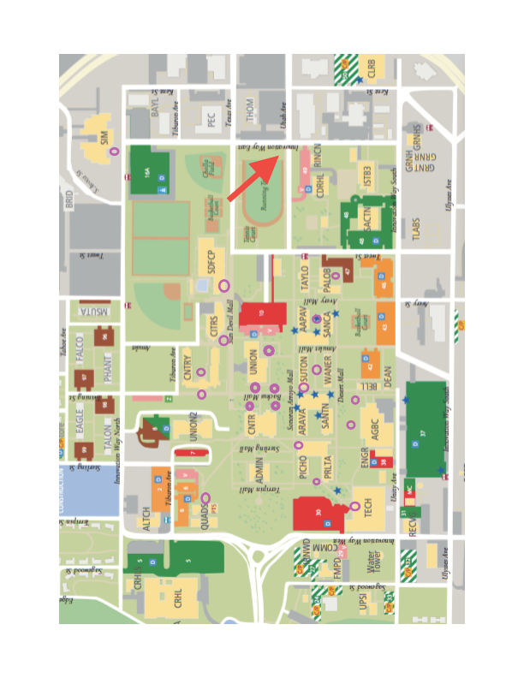
Viable locations for yard signs

*Map provided by the Programming and Activities Board

Marketing Locations on the Polytechnic Campus
Marketing Locations | Instructions for Hanging Posters
Palo Blanco Hall | Label quarter sheets with the location and distribute to the Quad 3 desk. Follow up to make sure they were distributed!
Century Hall | One poster for each floor, plus one for the front desk. Give to Century front desk to distribute, or distribute yourself. Check back to make sure it was done!
North Res Halls | Label quarter sheets with the location and distribute to the Quad 3 desk. Follow up to make sure they were distributed!
Housing Office (Quad 3) | Give to the Quad 3 front desk to hang up.
Poly Market | Give to Cashier, or hang yourself (with permission)
Santa Catalina | 1 on EACH side of bulletin board on 1st floor
Union | MUST be stamped at the Union front desk! 1 on board, 1 in each restroom. Flyers at the front.
Career Prep/Changemaker | Give to front desk for distributing.
Barrett Office | Give to front desk for distributing or hang on bulletin board.
Devil's Den | Get stamped at Union front desk! Give to student worker, or hang on the cork board (with permission)
Mesquite Cafe | 1 poster on board
Santan Hall | 1 on EACH side of bulletin board on first floor
Peralta Hall | 2 on EACH side of bulletin board on first floor
Tech Building | Pin to hallway boards
Agribusiness Center | BRING TAPE! Place on hallway board and tape to glass next to front door.
Citrus | 1 poster on board above condiments. Ask to place 1 poster at cashier.
Health Services | Give to nurses at front desk, hang one on board in Wellness Suite
SDFC | Give to front desk for approval and distributing
Computer Commons | Bring tape. Hang on wall inside computer commons. If they give you any trouble, find a space in the main lobby to hang instead.
Library | Give to front desk for distributing
SIM building | 1 on Bulletin board on first floor, give 1 to front desk on 2nd floor
*Locations and instructions provided by the Programming and Activities Board
Posting on asu.edu
To post on the ASU Events Website you must contact Lisa Robbins to be added as an administrator. lisarobbins@asu.edu

Volunteer & Event Staff Management
Recommended Timeline
12 Weeks Away
- Establish following information:
- Role(s) Description
- Role Shift Time
- Registration Deadline
- Using the system of your choice, create your registration using the registration questions below while being modified to your specific event:
- Name
- Email
- Phone
- What is your classification? (Ex: student, staff, alumni, donor, other)
- What is your department/school association? (Ex: SEMTE, Poly, EDO, ETS, CIDSE, alumni, outside ASU, etc.)
- Are you part of a Fulton engineering student org? Please type your organization.
- What is your ASU mail code, if applicable?
- Do you have any dietary restrictions? (Vegan, Vegetarian, Gluten Free)
- Print master copies of all role descriptions for you to have
10 Weeks Away
- Launch volunteer registration through your system of choice through the following methods:
- Engineering Staff distribution list (if applicable)
- Engineering Student distribution list (if applicable)
- Fulton Student Organization Monthly newsletter provided by Cortney Loui in Academic and Student Affairs
- Work with communications to produce the following regarding your volunteering opportunities:
- In the Loop article
- Inner Circle article
- Full Circle article
8-9 Weeks Away
- Re-announce your volunteer registration for your event through the following methods when you are 8 weeks away:
- Engineering Staff distribution list (if applicable)
- Engineering Student distribution list (if applicable)
- Fulton Student Organization Monthly newsletter provided by Cortney Loui in Academic and Student Affairs
- Work with communications to produce the following regarding your volunteering opportunities:
- In the Loop article
- Inner Circle article
- Full Circle article
- Establish the following information:
- Check-In
- Check-Out
- Area Leads (if applicable)
- Food
- Volunteer Hospitality Location
- Wardrobe
- Parking/Transportation
- Deans Funding Points
- Radios
- Supplies Needed
5-8 Weeks Away
- Re-announce your volunteer registration for your event through the following methods when you are 6 weeks away:
- Engineering Staff distribution list (if applicable)
- Engineering Student distribution list (if applicable)
- Fulton Student Organization Monthly newsletter provided by Cortney Loui in Academic and Student Affairs
- Work with communications to produce the following regarding your volunteering opportunities:
- In the Loop article
- Inner Circle article
- Full Circle article
- Start to create your agenda(s) to include following information:
- Check-In
- Check-Out
- Area Leads & Crew
- Food
- Volunteer Hospitality Location
- Wardrobe
- Parking/Transportation
- Deans Funding Points
- Radios
- Volunteer Cord. Contact Information
4 Weeks Away
- Re-announce your volunteer registration for your event through the following methods when you are 4 weeks away:
- Engineering Staff distribution list (if applicable)
- Engineering Student distribution list (if applicable)
- Fulton Student Organization Monthly newsletter provided by Cortney Loui in Academic and Student Affairs
- Work with communications to produce the following regarding your volunteering opportunities:
- In the Loop article
- Inner Circle article
- Full Circle article
3 Weeks Away
- Close volunteer registration
2 Weeks Away
- Finalize volunteer agenda including the following information and any other important information the volunteers would need in order to do their job correctly
- Check-In
- Check-Out
- Area Leads
- Food
- Volunteer Hospitality Location
- Wardrobe
- Parking/Transportation
- Deans Funding Points
- Radios
- Volunteer Cord. Contact Information
- Create name badges to include:
- School logo
- Name
- “volunteer” at the bottom
One Week Away
- Email ALL volunteers the following information:
  - Agenda including information below (if it applies)
    - Check-In
    - Check-Out
    - Area Leads
    - Food
    - Volunteer Hospitality Location
    - Wardrobe
    - Parking/Transportation
    - Deans Funding Points
    - Radios
    - Volunteer Cord. Contact Information
  - Maps
  - Job Descriptions
  - Schedules
  - Anything else that is specific towards your event
The Week of the Event
- Update volunteer registration with any late additions or cancellations
- Print any additional nametags needed due to late signups
- Give guarantee to caterers for food regarding volunteers (3 days prior to event)
- Print all master forms for day of and create master volunteer binder of everything you would think you need to know to volunteer at the event
- Create volunteer sign in AND sign out sheet
- Create volunteer walk-up sign in sheet
- Create volunteer deans funding sign in and our sheet
- Provide a half-page description of all job descriptions so they can review their duties upon arrival
- If you didn’t do an electronic waiver, make sure you bring enough copies of the required waiver for every volunteer to sign and turn in at check-in
- Pack all supplies for volunteers and volunteer hospitality
  - Master Volunteer Binder
    - All job descriptions
    - Schedules
    - Agendas sent
    - Maps
    - History of all major communications with volunteers
    - Timelines
    - List of all volunteers by name; by area; by job
    - Food contracts and eligible volunteers for food list
    - Anything else that applies
  - Volunteer Emergency Kit
    - Pens
    - Pencils
    - Highlighters
    - Sharpies
    - Markers
    - Crayons
    - Colored pencils
    - Packing tape
    - Desk tape
    - Scissors
    - Rubber bands
    - Paper clips
    - Kleenex
    - Stapler
    - Staple remover
    - Door stops
    - Small notepads
    - Mini first aid kit
    - Hand sanitizer
    - Sunscreen lotion
    - Few sheets of card stock/colored paper
  - Sign In Sheets
    - Deans Funding
    - Walk-Up volunteers
    - Regular sign in sheet for registered volunteers
  - Required ASU Volunteer Waivers and a few clipboards dedicated to the waivers
  - Name badges for each volunteer with lanyard
  - Wristbands for each volunteer that is eligible for food (typically stuffed in the name badge of the eligible person)
  - Extra wristbands
  - 50 extra blank name badges and lanyards for walk up volunteers
  - T-shirts (if applicable)
  - Water
  - Snacks
  - Rocks or paper weights in case your event is outside and is windy
  - 4 banquet tables to setup volunteer check-in and linen if you feel like making it a bit more official
Within 1 Week after the Event
- Send individual hand written thank you cards to all STAFF volunteers
- Send individual email to all STUDENT volunteers
- Update no shows and cancellations in online registration
- Send Deans Funding Points sign in sheets to ASA/Fulton Student Orgs. Coordinator
- Send all volunteers a brief survey regarding their experience as a volunteer during pre-event communications, at event experiences, and post-event evaluation from their perspective, and most importantly, would they come back next year?
Information provided by: Kristin Olafs

Contacting Non-ASU Vendors for Events
There are a few things to keep in mind when reaching out to businesses to contract services for an event.
Before the initial contact:
- Know exactly what type of external services are needed for the event
  - Summarize the needs and specifications in a way the vendor can understand it
- Does the preferred vendor(s) for the event already have a special contract or record with ASU?
  - Ex: Preferred Food Provider list, Bus Charter Companies
- Understand what paperwork is needed from the vendor to conduct business with them
  - Prepare to gather quotes, invoices, and Bill of Material
  - Make sure the vendor knows to supply the necessary documents to conduct their service.
- Be aware and prepared to generate a special contract with the vendor if the type or cost of the service(s) require it. It takes time to generate and approve special contracts.
  - Inform applicable management of the impending contract
  - Understand how to explain the contract process to vendors
Preparing for possible negotiation with vendor:

- Completely understand needs for event
- Have a budget for this service and a set negotiable price range for vendor
- Have a good understanding of vendor’s capabilities
- Research vendor’s past service history with ASU
- Know the event planning timeline
A video with great tips on general negotiation skills: “Negotiation Skills Top 10 Tips” https://www.youtube.com/watch?v=oy0MD2nsZVs
When contacting vendor:
- Research and know who the contact person is for the company
- Contact at the earliest, reasonable time in the event planning stage in case issues arise
- Keep records of communication with this vendor(s)
- Make sure they know day-of-event itinerary
After the event:
- Make sure they have received all of their property back (if applicable)
- Thank them for their service
- Keep all of their paperwork for records
- If their service was great, keep them in mind for future events

Event Sustainability
Arizona State University has a commitment to be a sustainable campus and have put together some tips and guidelines to help event planners host sustainable events. Find all of the information through this link: https://specialevents.asu.edu/events101/sustainability
Green Event Program: https://eoss.asu.edu/sites/default/files/Green-Event-Checklist_1.pdf
Lesley Forst, University Sustainability Practices Lesley.forst@asu.edu (480) 965-9330
Alana Levine, Zero Waste: Alana.Levine@asu.edu or 480.305.4566

Appendix
  - SDFC Layouts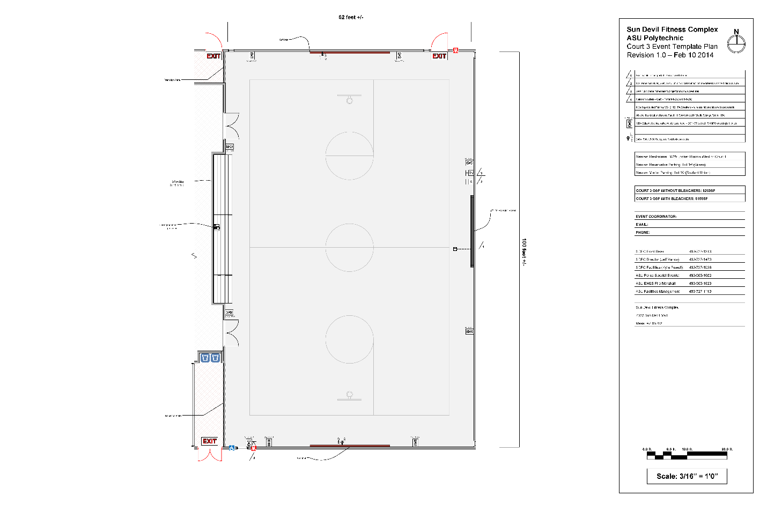
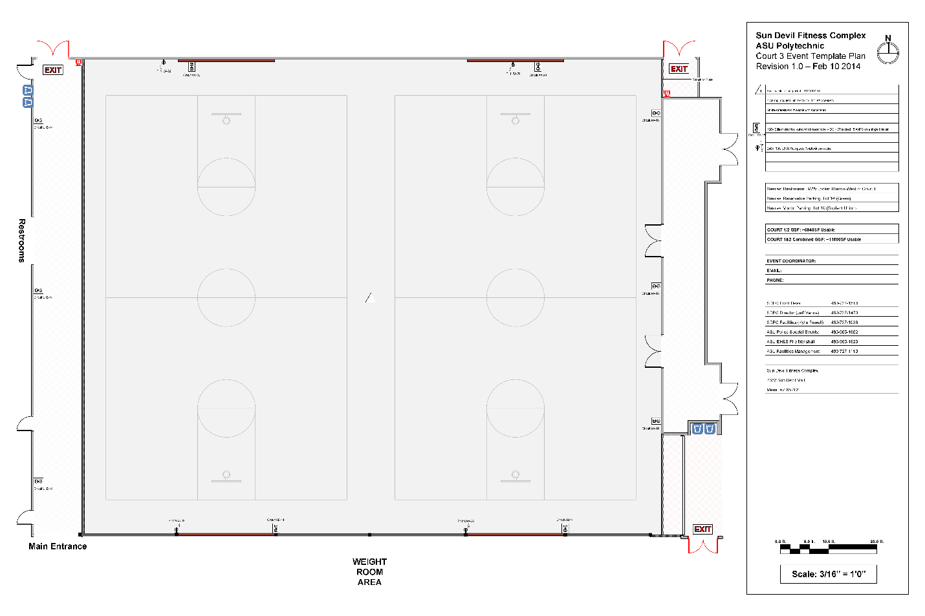
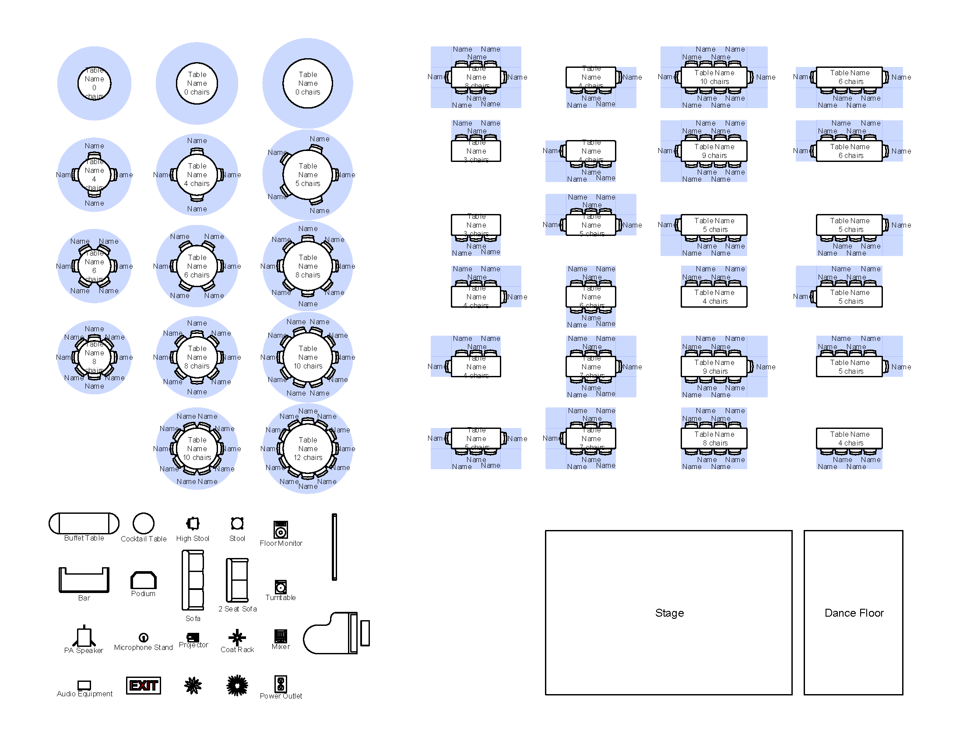
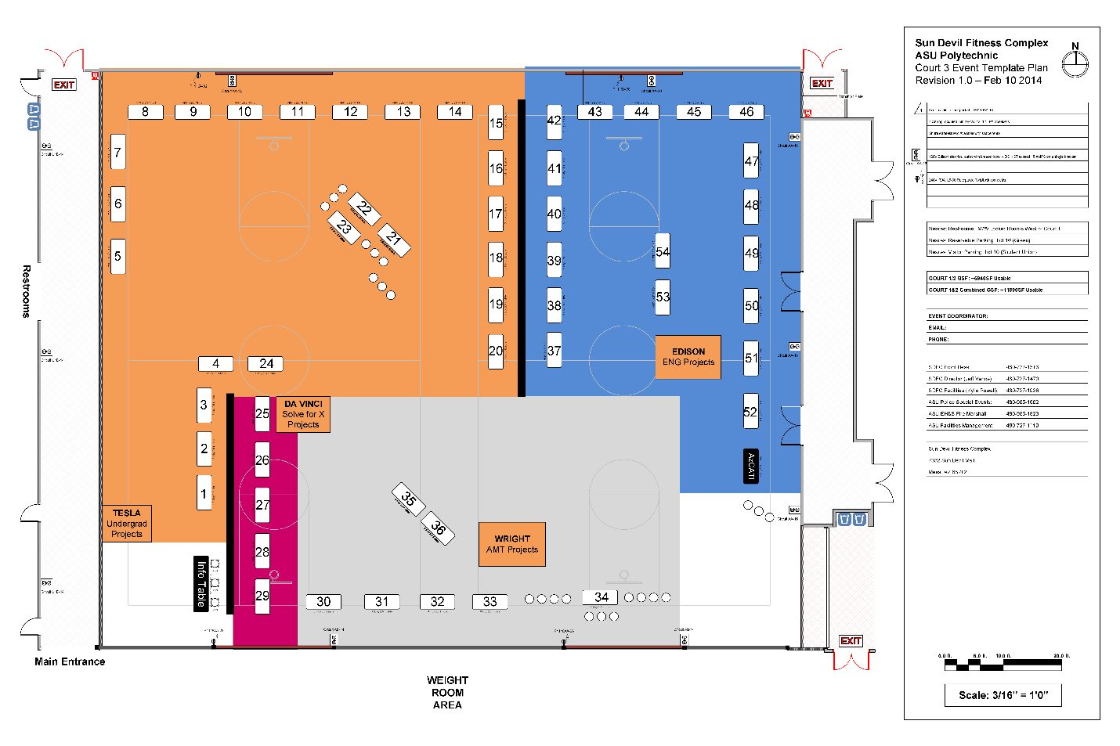
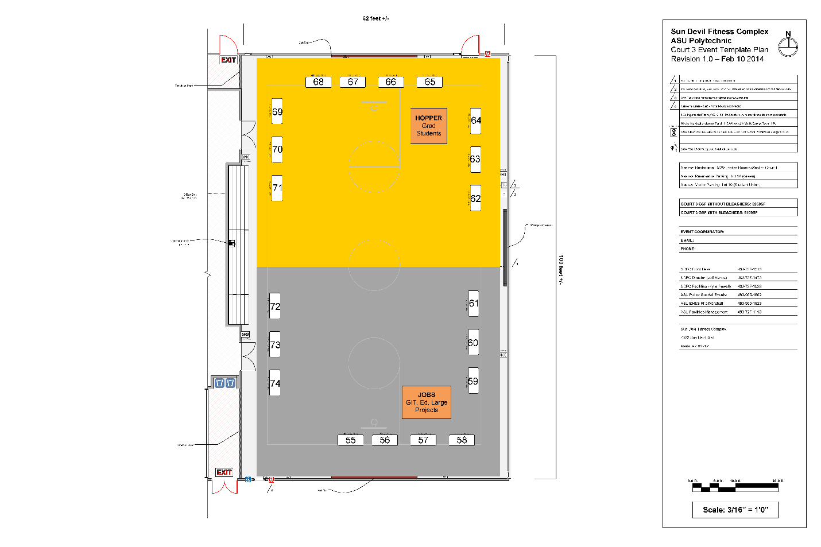
  - CoOley Ballroom Layouts

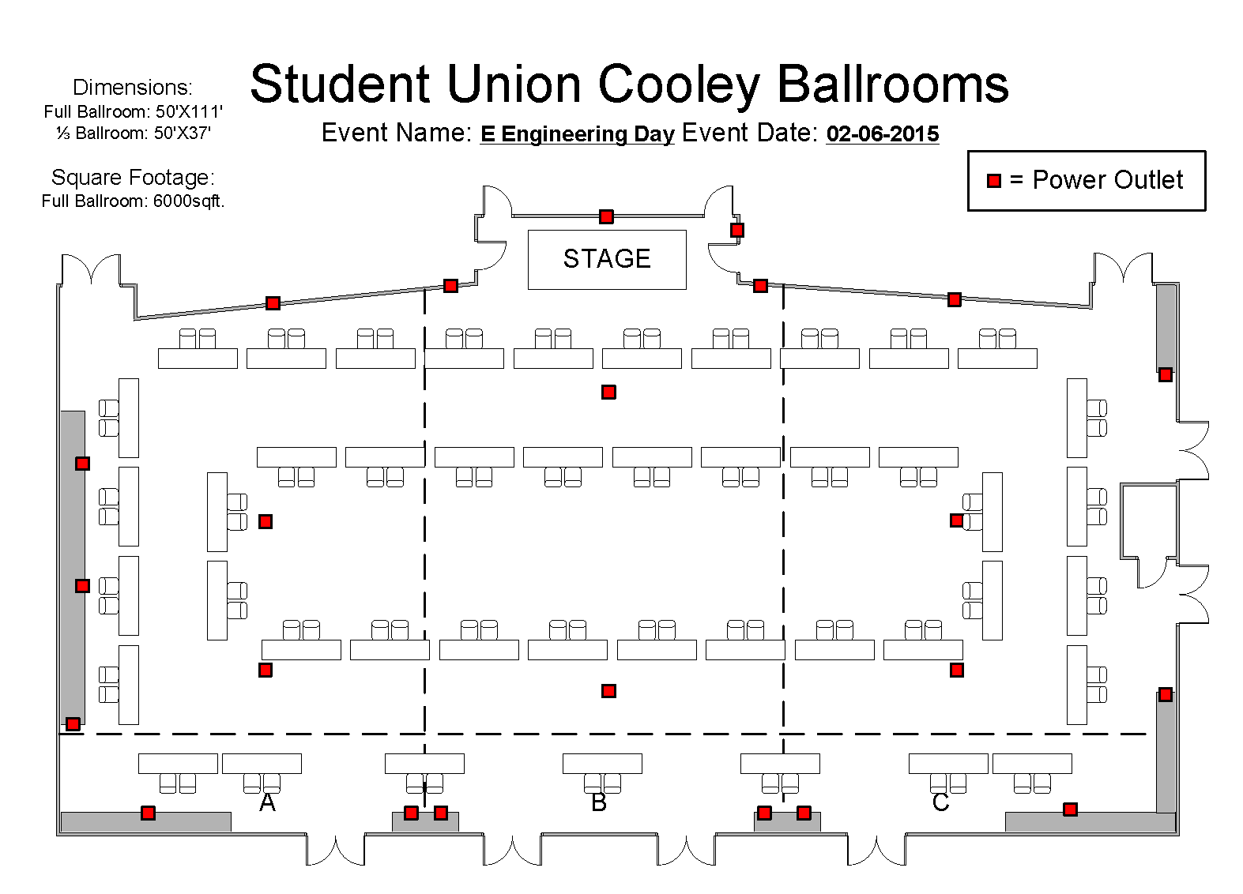
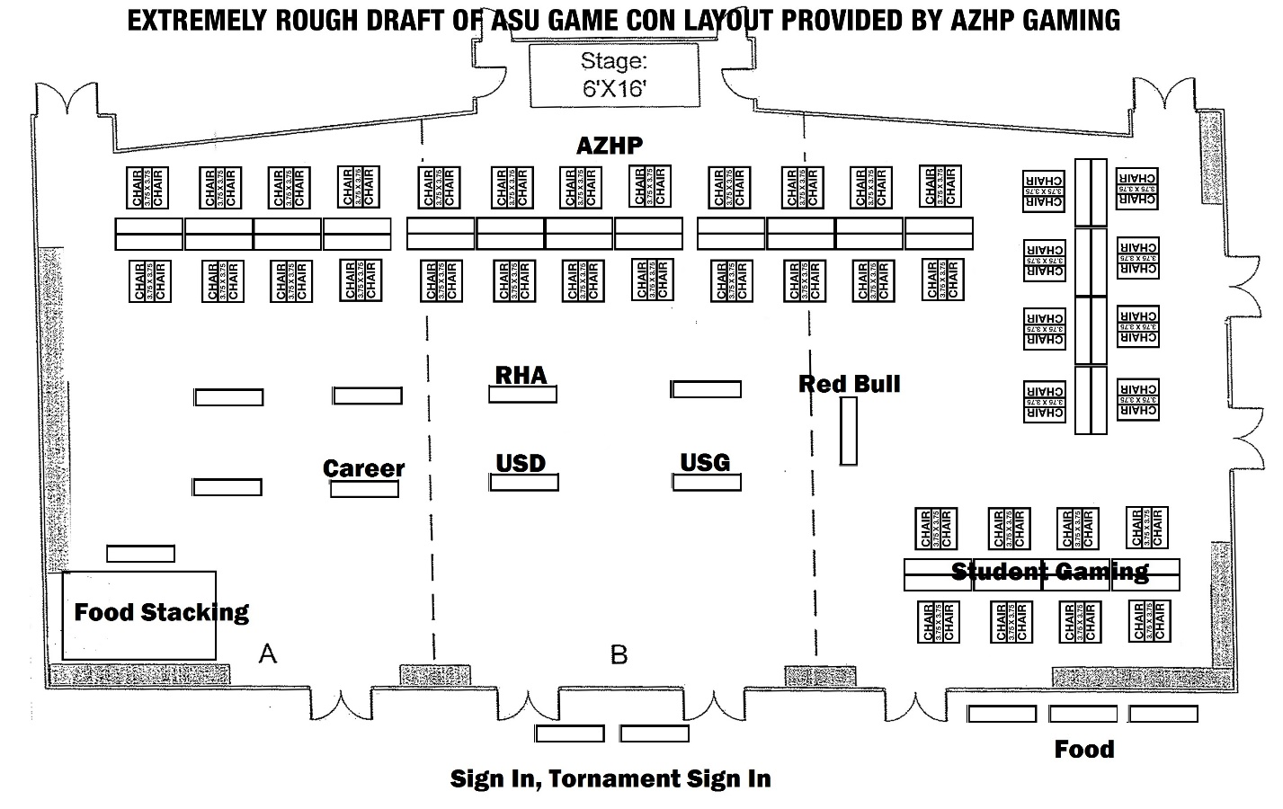

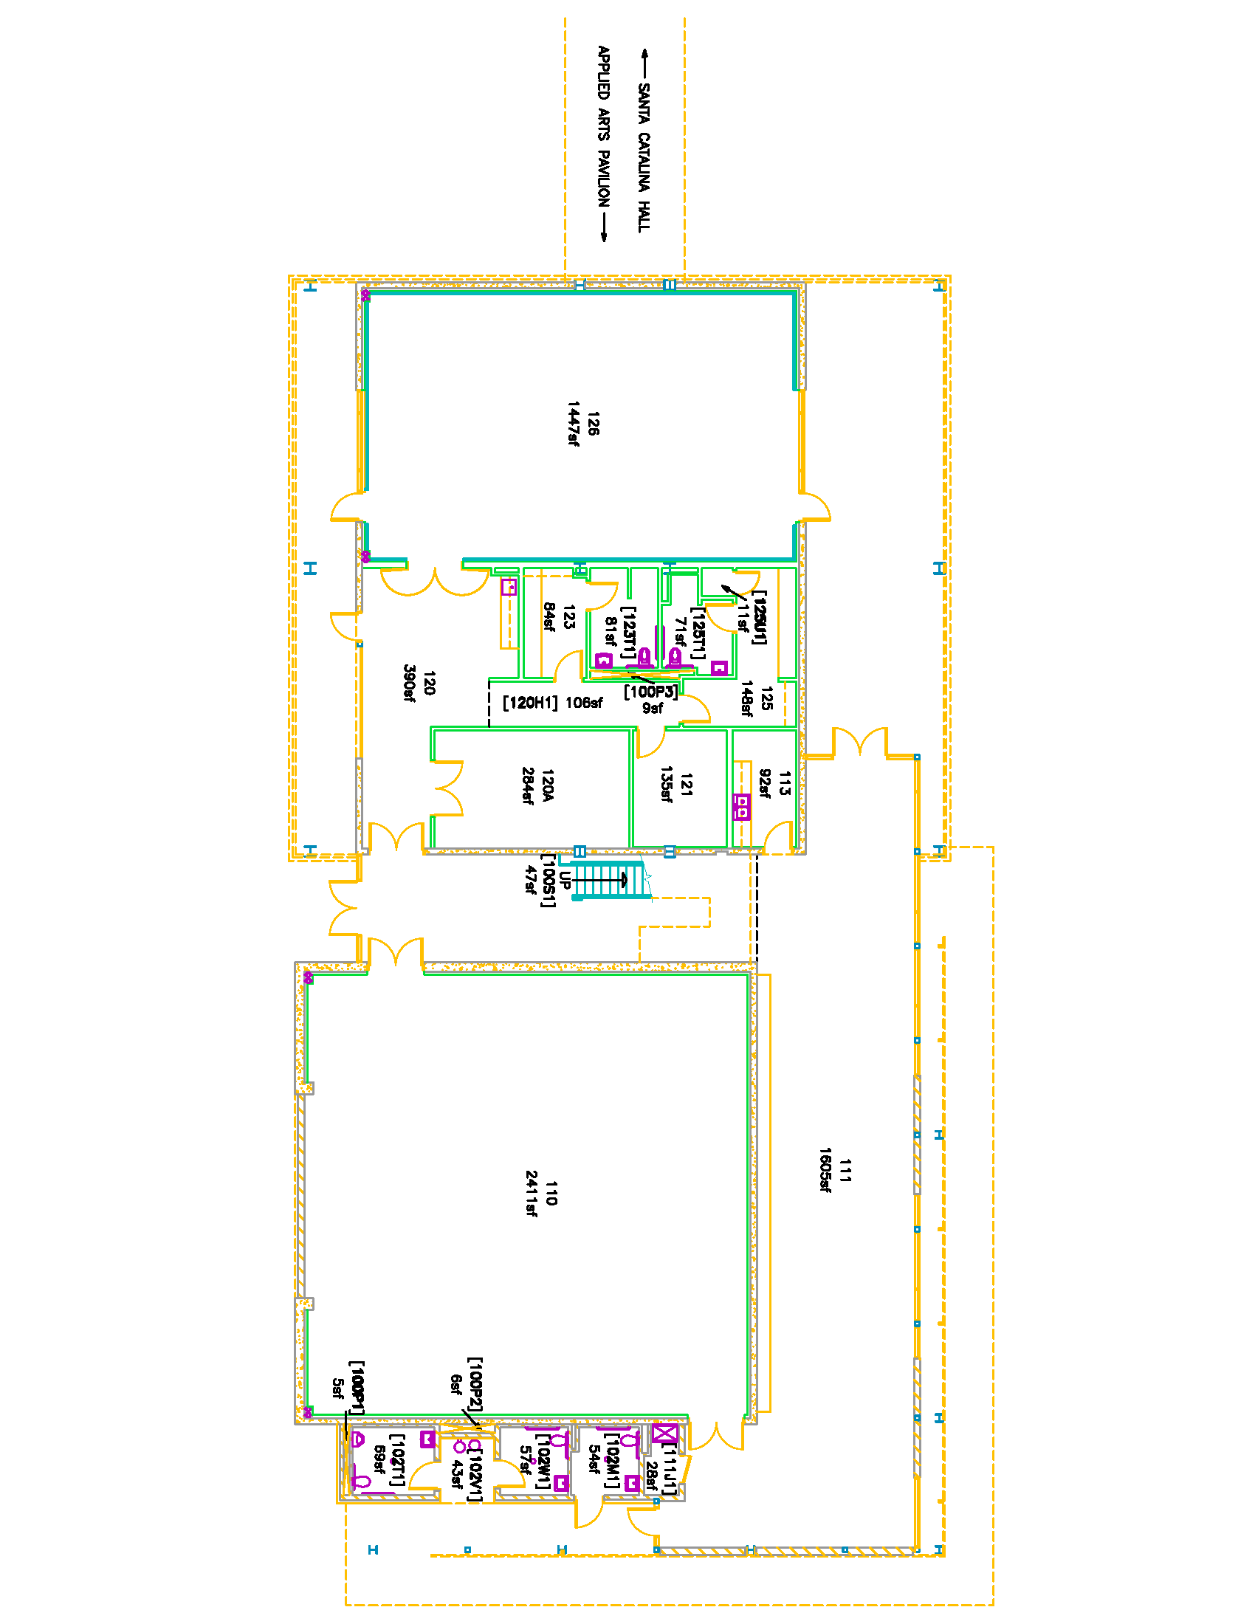
  - Applied Arts Pavillion & Black Box Theater Layouts
